In this document you will have brief introduction about
1. What is a Server
2. What is Hypervisor
3. What is a Virtual Machine
4. How Docker introduced and its importance
5. How an application will convert to docker image and then how it is converting as a container and
6.
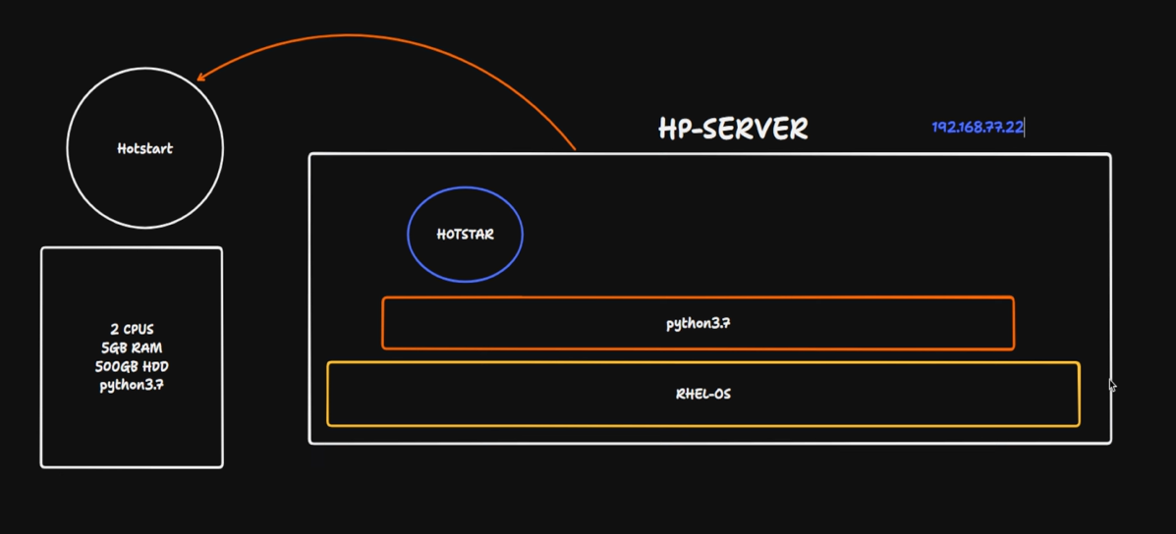

One application python language based named “hotstar” is deployed in RHEL based OS
the server IP 192.168.77.22
2. Form client server when user type hotstart.com
DNS[ Application layer protocol ]192.168.77.22 it will go ISP and start check in router gateway then if not found then It will check from internet for the domainthen server will give result
case-2: Another application is deployed in same server and now the python version is changes to 3.7 to 3.1 , then second application will work but first application will give conflicts
2. So, deployment team decided to deploy in different servers
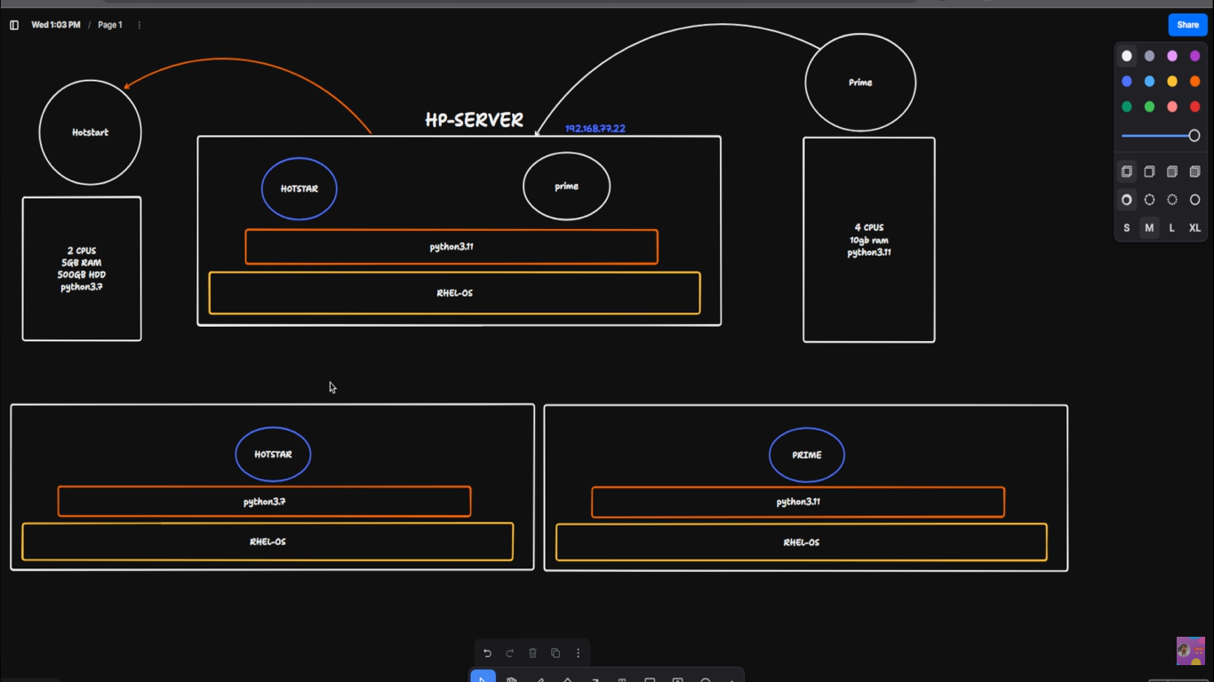
The actual problem is not installing the required things in systems, but if you are having more than 10 systems or 50 and 100 systems, checking health and maintenance of the systems
To resolve this issue hypervisor came into market explained below. To avoid this, we VM Ware came into market.
- Hypervisor: VMware's software, called a hypervisor, is a layer that sits between the physical hardware and the virtual machines.
- Resource sharing: The hypervisor manages and allocates the physical server's resources to each virtual machine, which otherwise would be a separate, physical server.
- Virtual Machines (VMs): Each VM functions as a separate computer with its own operating system, applications, and resources, but they all share the same underlying physical hardware.
- Isolation: If one VM crashes or is infected with malware, it does not affect the others on the same physical server, providing security and stability.
On windows 11 OS hypervisor tool is installed and using vm-ware workstation will create different virtual machines as showed in the picture. this type of hypervisor called type-2 hypervisor.
In type-2 hypervisor virtual machines are created and used by VM-ware workstation tool.
note: Here HP-server name is nothing just for naming convention, it is just like a server.
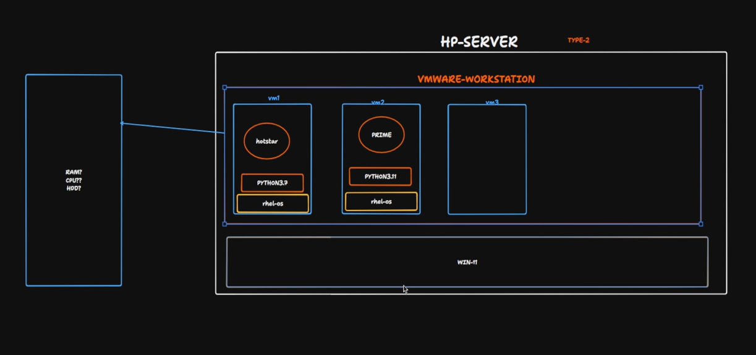

Type -1 Hypervisor:
Type-1 hypervisor is called as actual hypervisors. The server itself directly comes with an esxi and it is CLI based software. On top of its V-Center tool is installed as GUI based application.
When you used V-Center to create a new VM in background Hypervisor[esxi] will take care of these things.
NOTE: As like windows, Linux, and ubuntu esxi is an software

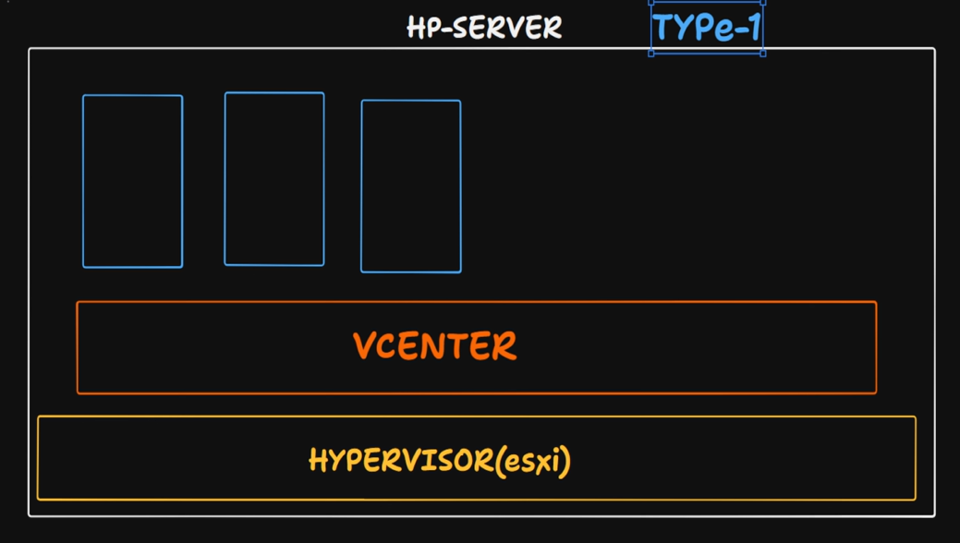

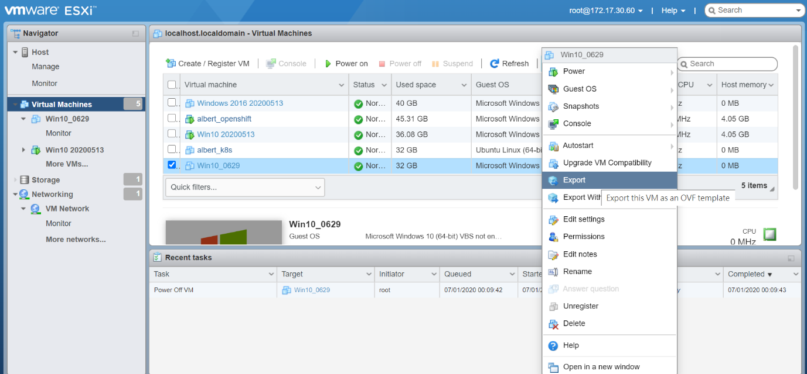
While creating VM in VM-ware workstation the allocated ram should be 4 gb at least to run windows 10 or windows 11 without any lag Even though deployed applications will use 50 mb or 500 mb of ram. , In this process from bare system OS should be used same physical system and as like that if you want 10 VM’s then the maintenance and allocated things budget will be more. To avoid this container concept came into market.

Containers:
To create container, you need an image
In this current case : Think We have converted our hotstar application converted in to an image and then wrapped into a container as showed In the below screenshots.
In below screenshots RHEL-OS box is base OS and container-runtime box is a kind of tool and in circle the hotstar application. Now hotstar application converted as hotstar image which contains light weight OS of 50mb of usage storage and 4 mb of ram only.
We converted our hotstar application into image and then wrapped into container which is blue square box
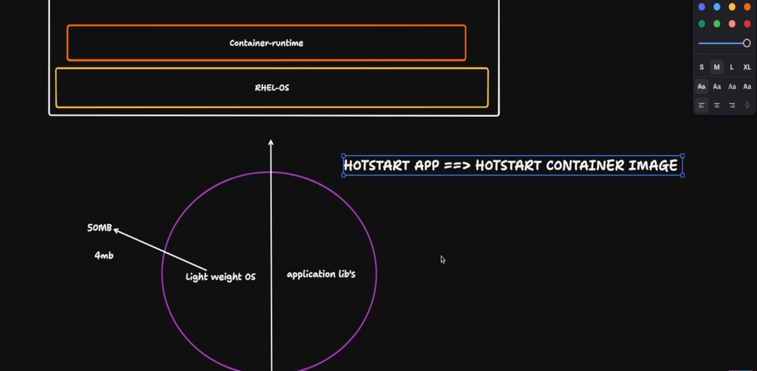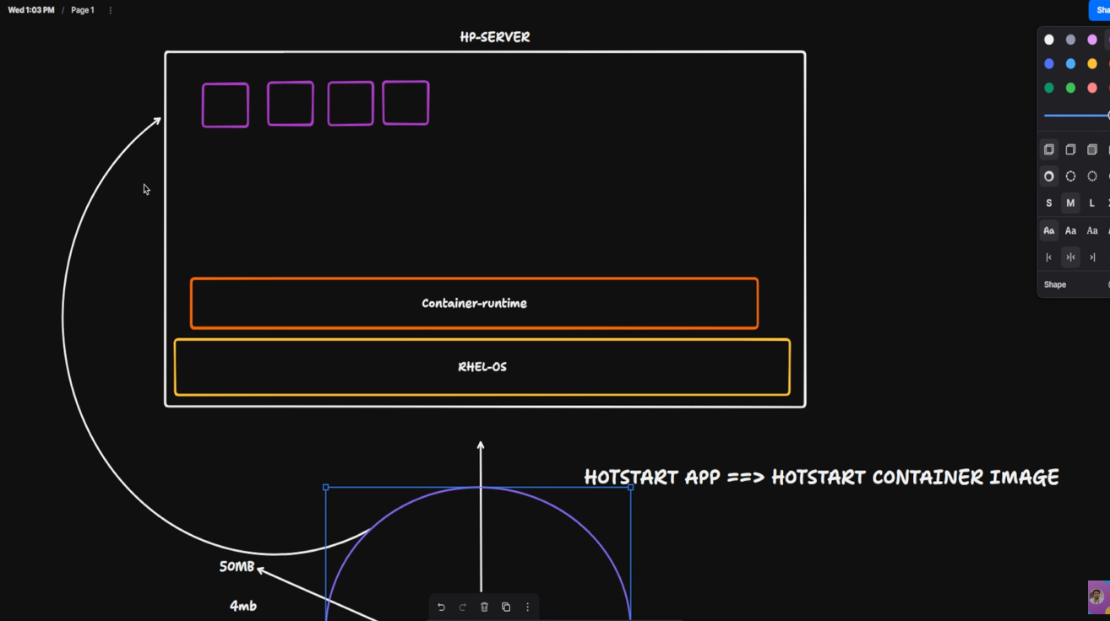

Hotstar application Hotstar image Hotstar container
Now the main drawback is if you want to maintain 100’s of VM’s in different machines. To resolve this another tool is introduced called as “Kubernetes -k8s” orchestration tool.
In below screenshots blue circles are considered as “containers”. So, if any of the container is not running or not working or to restart if stopped.
K8s will automatically take maintenance of the machines and as well as containers also.
For an example if one of the containers is not working then k8s will take of that container and restart and run that container as like previous.
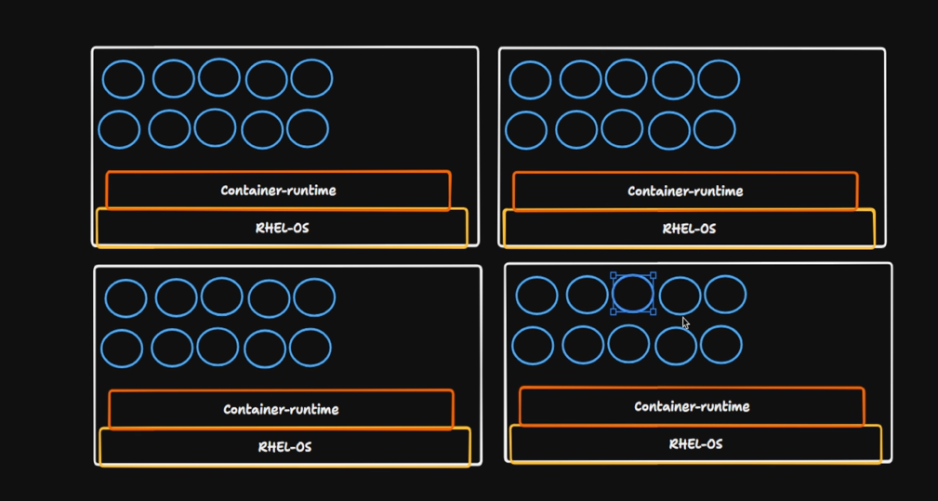
K8s will take care if any of the container will be down, and it will restart as showed in below image.
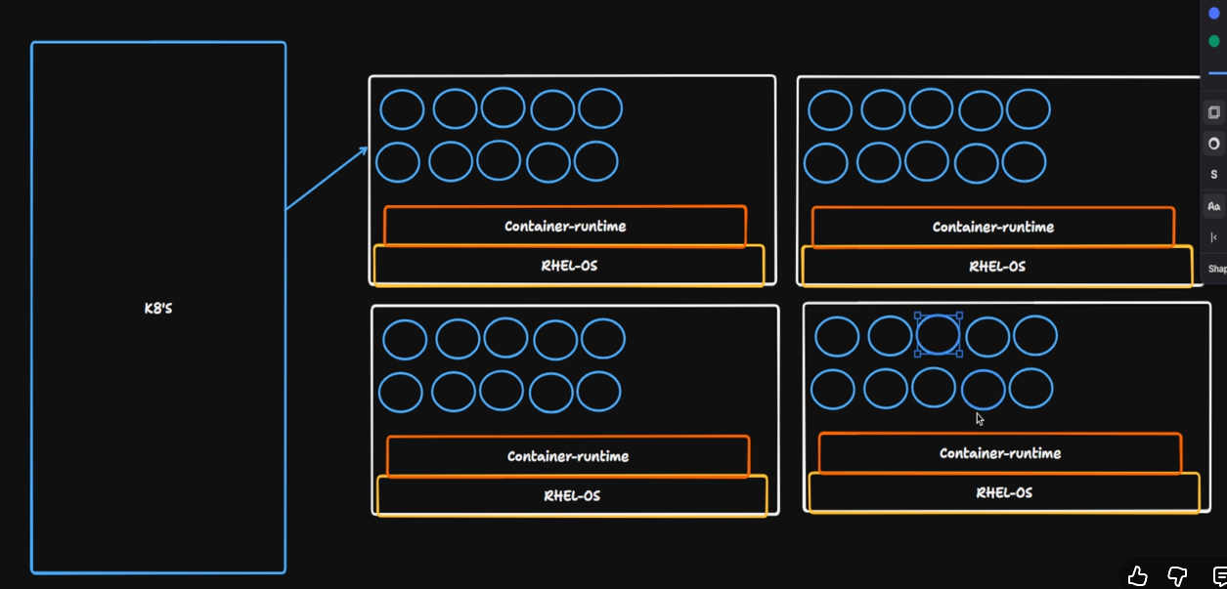

Below part will be in the interview point of view which is equivalent of 2-3 years of experience
Why Were VMs, Docker, and Kubernetes Introduced?
1. What is a Server?
A server is a powerful computer that provides services or applications to other machines (called clients) over a network.
Example scenario
- OS: RHEL (Red Hat Enterprise Linux)
- Application: Python-based “Hotstar” web application
- Server IP: 192.168.77.22
From the client side, when a user types:
hotstar.com
this happens:
- DNS Resolution (Application Layer)
In computer networks there will be 7 layers, and you must read about all those things
  - The browser asks a DNS server to resolve hotstar.com → IP address.
  - DNS returns an IP (for our example story, think of something like 192.168.77.22 or a public IP mapped to it).
- Routing the Request
  - The request goes from:
    - Client → Local Router [Home]→ ISP → Internet → Target server IP.
  - Network devices (routers, gateways) use that IP address to route traffic to the right server.
- Server Response
  - The RHEL server receives the HTTP/HTTPS request.
  - The Hotstar application processes it and returns the response (HTML, JSON, video stream, etc.) to the client.
So far, this is a simple single-server, single-app architecture.

2. The Problem: Multiple Apps with Conflicting Dependencies
Now, imagine this situation on the same RHEL server:
- App 1 (Hotstar v1)
  - Requires Python 3.7
- App 2 (New Hotstar feature / another Python app)
  - Requires Python 3.11 (or a different major version)
If you:
- Upgrade system-wide Python from 3.7 → 3.11 →
  - New app works
  - Old app may break due to dependency incompatibilities
- Try to force multiple Python versions and packages on the same OS →
  - You get dependency hell:
    - Version conflicts
    - Library mismatches
    - Difficult rollbacks & maintenance
Deployment team’s decision
To avoid this conflict, the deployment team decides:
“Let’s deploy each major app on a separate server.”
This works functionally, but introduces new problems:
- More physical servers to buy
- More power / cooling / rack space
- More maintenance (patching, monitoring, hardware failures, etc.)
We need a better way to isolate environments without buying a separate physical server for each app.

3. Hypervisors and Virtual Machines (VMs)
This is where hypervisors and virtualization come in.
What is a Hypervisor?
A hypervisor is a software layer that sits between the physical hardware and virtual machines. It allows multiple virtual machines (VMs) to share the same physical server.
Key responsibilities:
- Allocate CPU, RAM, storage to each VM
- Run multiple isolated OS instances on one physical box
- Ensure separation between VMs

What is a Virtual Machine (VM)?
A VM is a virtual computer running on top of a hypervisor.
Each VM has:
- Its own virtual CPU, RAM, disk
- Its own OS (Windows, Linux, etc.)
- Its own applications and libraries
From inside, it feels like a real machine.
Benefits of VMs
- Isolation
  - If one VM crashes or gets infected with malware, others on the same host remain safe.
- Better resource utilization
  - Instead of running one OS per physical server, you can run many VMs on the same physical box.
- Flexibility
  - You can run different OSes on the same hardware: RHEL, Ubuntu, Windows, etc.

4. Type-2 Hypervisor (Example: VMware Workstation)
On our Windows 11 laptop, when you install VMware Workstation, you are using a Type-2 hypervisor.
- Type-2 Hypervisor:
  - Runs on top of a host OS (like Windows 11).
  - Example tools: VMware Workstation – The company name itself is “VMware”
Oracle VirtualBox -introduced by Oracle company
  - You create VMs in the UI and assign CPU/RAM/Disk.
Example:
- Host: Windows 11
- Hypervisor: VMware Workstation
- VMs:
  - RHEL-VM-1 (for Hotstar app with Python 3.7)
  - RHEL-VM-2 (for another app with Python 3.11)
  - Windows-VM (for other tools)
Note: A VM name like “HP-Server” is just a name for identification; it’s not a real HP physical server. It’s simply a VM running on your host.

5. Type-1 Hypervisor (Example: VMware ESXi)
In data centres, we generally use Type-1 hypervisors.
- Type-1 Hypervisor (Bare-metal):
  - Runs directly on the physical server hardware.
  - No separate host OS like Windows/Ubuntu under it.
  - Example: VMware ESXi, Microsoft Hyper-V (bare metal), KVM on Linux (with some differences in terminology).
With VMware:
- Physical server (e.g., Dell/HP) → installed ESXi hypervisor.
- ESXi provides a platform to create and manage VMs.
- vCenter:
  - A GUI-based management tool that connects to multiple ESXi hosts.
  - Used to:
    - Create, modify, migrate VMs
    - Manage clusters, HA, DRS, etc.
ESXi is a specialized hypervisor OS. You can think of it as “an operating system whose main job is running VMs”.

6. The Problem with VMs: Heavyweight and Costly
Now let’s look at resource usage.
Example: Creating a Windows 10/11 VM in VMware Workstation:
- You allocate:
  - 4 GB RAM (minimum for comfortable use)
  - Some CPU cores
  - 40–60 GB disk
Even if your application inside uses only:
- 50–500 MB of RAM,
the OS itself already consumes a few GB of RAM.

So, for each VM, you pay a cost in:
- OS boot time
- RAM, CPU usage
- Disk space
- OS patching (Windows Update, yum/apt update, etc.)
If you want 10 VMs on a single host:
- Total RAM, CPU requirements become huge.
- License cost, infrastructure cost, management overhead all grows.
This is where containers come into the picture.

7. Containers and Docker
What is a Container?
A container is a lightweight, isolated environment that runs your application and its dependencies on top of a shared host OS kernel.
Instead of virtualizing the entire hardware + OS (like a VM does), containers:
- Share the same OS kernel as the host
- Package only:
  - Your application
  - Required runtimes (e.g., Python)
  - Libraries and configuration
This makes containers:
- Much lighter than VMs
- Faster to start/stop
- Easier to move across environments (build once, run anywhere)
Image vs Container
- Image:
  - A read-only template with:
    - Application code
    - Runtime (Python, Java, Node.js, etc.)
    - Dependencies, config, OS user-space (Alpine, Ubuntu base)
  - Example: hotstar:1.0
- Container:
  - A running instance of an image.
  - You can start/stop/delete containers as needed.
Our Hotstar example with containers
- We build a Docker image for Hotstar:
  - Base image: lightweight Linux (e.g., Alpine, Ubuntu minimal)
  - Install required Python version (say Python 3.7)
  - Copy Hotstar code and dependencies
- We run it as a container:
  - The host OS might be RHEL, Ubuntu, or even Windows with Linux containers.
  - The container runtime (Docker Engine or container) runs the container.
Instead of saying “lightweight OS of 50 MB and 4 MB RAM” (which is unrealistically small), it’s better to say:
The image is much smaller than a full VM.
Containers can often start in milliseconds to seconds and use significantly fewer resources compared to full VMs.
Why containers solve our earlier problems
- Different apps with different Python versions?
  - Put each app in its own container image with its own Python runtime and libraries.
- No conflicts at OS level:
  - Host OS just runs the container runtime.
  - Each app sees its own isolated filesystem, libraries, and processes.

8. But Containers Bring a New Challenge: Management at Scale
Now imagine:
- You are running hundreds of containers across multiple servers:
  - Hotstar frontend containers
  - Backend containers
  - Recommendation service containers
  - Logging, monitoring containers, etc.

Questions arise:
- How do you restart containers automatically if they crash?
- How do you scale from 2 containers → 20 containers when traffic increases?
- How do you balance load between all containers?
- How do you roll out zero-downtime deployments (blue/green, rolling updates)?
- How do you manage config, secrets, and service discovery?
Manually doing this with plain docker run becomes impossible. To resolve these conflicts
We need an orchestration tool. Then the tool named “Kubernetes” got introduced.

9. Kubernetes (K8s): Container Orchestration
Kubernetes (K8s) is an open-source container orchestration platform.
Its main job:
Maintain the desired state of your containerized applications in a cluster of machines.
Key Concepts (3-year-level brief)
- Node:
  - A machine (VM or physical) that runs containers.
- Pod:
  - The smallest deployable unit in Kubernetes.
  - Usually, a Pod = 1 container (sometimes more, tightly coupled).
- Deployment:
  - Defines the desired state:
    - Which image to run
    - How many replicas (Pods)
    - Update strategy
- Service:
  - Provides a stable IP / DNS name to access a group of Pods.
  - Handles basic load balancing.
What Kubernetes does for you
- Self-healing:
  - If a Pod (container) crashes, K8s automatically creates a new one to match the desired replica count.
- Auto-scaling (with HPA):
  - Scale the number of Pods based on CPU/memory/utilization metrics.
- Rolling updates & rollbacks:
  - Deploy new versions of your app without downtime.
  - Roll back if something goes wrong.
- Service discovery & load balancing:
  - Pods get replaced all the time; Services provide a stable way to reach them.
Relating to your diagram description
In your earlier version, you said:
“In below screenshots, blue circles are containers. If any container is not working, K8s will restart it.”
That’s conceptually correct. More precisely:
- You define a Deployment with, say, 3 replicas of the Hotstar container.
- Kubernetes Scheduler ensures 3 Pods are running on the cluster nodes.
- If 1 Pod stops:
  - Kubernetes detects it and starts a new Pod to maintain 3 replicas.
  - This is called self-healing.
So, Kubernetes doesn’t “fix” the broken container; it replaces it by creating a new one based on the image and spec you defined.

10. Summary: Why These Technologies Were Introduced
- Single Server (Bare Metal)
  - Simple but:
    - Dependency conflicts (Python versions, library versions)
    - Hard to isolate applications
    - Scaling = more physical servers
- Hypervisor + VMs
  - Separate OS per app → strong isolation
  - Better utilization than one app per physical server
  - But:
    - Heavy (full OS each time)
    - High resource usage and maintenance
- Containers (Docker)
  - Lightweight, fast, portable
  - App + dependencies packaged into images
  - Share host OS kernel → less overhead than VMs
  - But:
    - Managing hundreds/thousands of containers manually is difficult
- Kubernetes (K8s)
  - Orchestrates containers across a cluster
  - Provides:
    - Self-healing
    - Scaling
    - Load balancing
    - Rolling updates
  - Becomes the standard for running microservices at scale.

